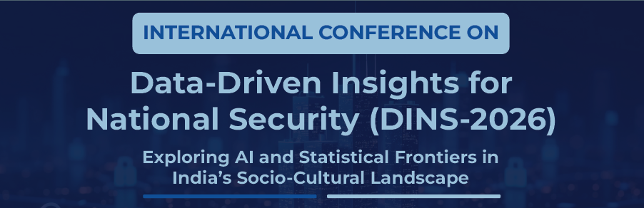
(30th – 31st March 2026)

DINS-2026 Special Session on
“Insert Your Special Session Title Here”

Aims and scope of the session:
The special session explores the
………….

Topics of interest:
The special session track will cover a wide range of topics related to ……. (but not limited to):
- Threat detection to decision intelligence

………….
Special session organizers:
- Organizer-1 Name
Affiliation
email (contact no.)

Dr. Abcd Efgh is currently ………. | [Photo]

- Organizer-2 Name
Affiliation
email (contact no.)
Dr. Ijklm Nopq is currently ………. | [Photo]

………….

